1. Experiment Name
Design, Tuning, and Optimization of a Laser-Based Analog Audio Transmission System (Li-Fi).

2. Theory
Optical audio transmission utilizes a light source to carry analog electrical signals across free space via intensity modulation. In the transmitter stage, a UA741 operational amplifier and a BD139 power transistor actively modulate the current passing through a 5 V laser diode. Because an audio waveform consists of alternating positive and negative voltage swings, the laser must be biased to a resting state of 50% brightness. This prevents the negative half of the audio wave from turning the laser completely off, which would cause severe non-linear distortion.
The receiver relies on an ST-1KLA phototransistor to convert the fluctuating light intensity back into a variable current. A tuned pull-up resistive network (combining a 220 Ω safety resistor and a 10 kΩ potentiometer) translates this current into a voltage signal. To maximize signal integrity and prevent optical saturation from the intense laser beam, the pull-up network is tuned so the resting collector-to-emitter voltage (VCE) sits at exactly half of the supply voltage (VCC/2). The recovered AC audio signal is decoupled from the DC bias via a 1 µF capacitor and fed into an LM386 audio amplifier to drive an 8 Ω speaker through a 470 µF output capacitor, ensuring full bass frequency response.

3. Circuit Diagram
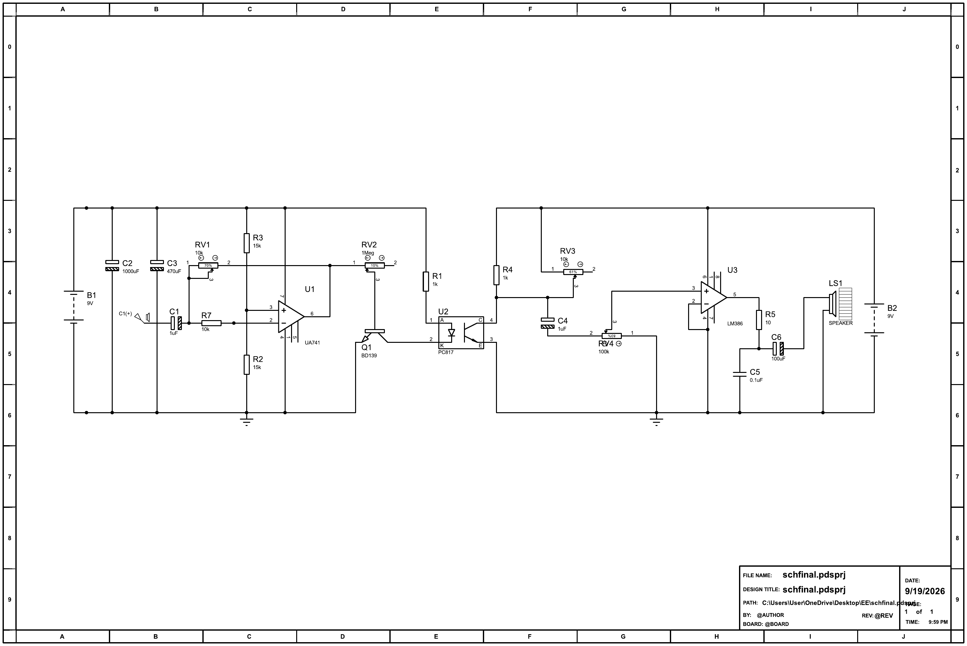

4. Components Required
Transmitter Section
Component | Quantity
UA741 Operational Amplifier | 1
BD139 NPN Power Transistor | 1
5V Laser Diode Module | 1
Electrolytic Capacitor, 10 µF–100 µF (Input coupling) | 1
Resistors, 10 kΩ and 15 kΩ (Op-amp bias network) | 1 each
Potentiometer, 100 kΩ (Volume / Gain) | 1
Potentiometer, 10 kΩ (Laser Brightness Bias) | 1
Receiver Section
Component | Quantity
LM386 Low Voltage Audio Power Amplifier | 1
ST-1KLA Phototransistor (opaque shielding + micro-diffuser tape) | 1
8 Ω Speaker | 1
Potentiometer, 10 kΩ (Phototransistor pull-up tuning) | 1
Potentiometer, 10 kΩ (LM386 volume) | 1
Fixed Resistor, 220 Ω (Safety limiter) | 1
Fixed Resistor, 10 Ω (Zobel network) | 1
Electrolytic Capacitors, 1 µF, 4.7 µF, 470 µF | 1 each
Ceramic Capacitors, 0.1 µF (Zobel network & rail decoupling) | 2

5. Procedure
- Transmitter Assembly: Construct the UA741 op-amp driver circuit. Ensure the input audio signal is decoupled using an electrolytic capacitor to preserve the DC bias.
- Laser Biasing: Without applying an audio signal, adjust the laser bias potentiometer until the laser diode illuminates at approximately 50% of its maximum safe intensity.
- Receiver Assembly: Construct the receiver circuit. Shield the ST-1KLA phototransistor with an opaque casing (leaving only the front lens exposed) and apply a translucent micro-diffuser over the lens to widen the optical acceptance angle and reduce alignment sensitivity.
- Optical Alignment: Position the transmitter and receiver facing each other. Aim the laser directly into the center of the phototransistor's lens.
- Receiver Tuning (VCC/2 Bias): Connect a digital multimeter across the phototransistor's collector and ground. Adjust the 10 kΩ pull-up potentiometer until the measured voltage is exactly half of the power supply voltage (e.g., 4.5 V on a 9 V supply).
- Gain Staging: Feed an audio signal into the transmitter. Slowly increase the transmitter gain potentiometer until audio is audible on the receiver speaker. If clipping occurs on heavy bass frequencies, slightly reduce the transmitter gain.

6. Data Table
Note: Theoretical voltage values are based on a nominal 9 V DC power supply.
Test Condition | Laser Status | Ambient Light | Phototransistor VCE | Audio Output Quality (Observed)
Dark Current | OFF | Shielded / Dark | ~9.0 V DC (open switch) | Absolute silence; no signal passing.
Ambient Interference | OFF | Exposed / Room Lights On | ~1.5–3.0 V DC (high AC ripple) | Continuous high-pitched beep, buzz, or white-noise hum.
Untuned Saturation | ON (Direct) | Shielded | ~0.1–0.5 V DC (closed switch) | Muted entirely, or heavily crushed and distorted audio.
Tuned (VCC/2 Bias) | ON (Direct) | Shielded | 4.5 V DC (ideal Q-point) | Clean resting state; ready for peak-to-peak AC swing.
Audio Transmission | ON (Modulated) | Shielded | 4.5 V DC ± 1.5 V AC | Crystal clear output, full bass response, no harsh clipping.

7. Report Questions
- Why is it necessary to establish a DC bias point (resting voltage) for the laser diode instead of driving it directly with the raw AC audio waveform?
Answer: A laser diode is a unipolar device: it only conducts and emits light when forward biased, and cannot produce “negative light” during the negative half of an audio cycle. If driven directly with the raw bipolar audio waveform, the negative half-cycles would simply cut the laser off, producing severe half-wave distortion instead of a faithful reproduction of the signal. By setting a DC bias point at the middle of the laser's linear operating range (approximately 50% brightness), the AC audio signal can be superimposed on top of this resting point so that positive half-cycles increase the brightness and negative half-cycles decrease it, with both excursions remaining within the diode's linear region. This allows the complete waveform to be linearly encoded as light-intensity variations without clipping.
- Explain the function of the 220 Ω fixed resistor placed in series with the 10 kΩ pull-up potentiometer on the receiver circuit. What failure condition does it prevent?
Answer: The 220 Ω resistor sets a guaranteed minimum resistance in the pull-up network regardless of where the potentiometer wiper is set. If the 10 kΩ potentiometer alone were used and turned all the way down to 0 Ω, a fully saturated phototransistor (under intense, direct laser illumination) would present almost no resistance, allowing an uncontrolled surge of current to flow through its collector-emitter junction directly from the supply. This could exceed the phototransistor's maximum rated collector current and destroy it. The 220 Ω resistor caps this current to a safe maximum value (I = VCC / 220 Ω) even at the lowest potentiometer setting, protecting the ST-1KLA from an over-current/thermal failure while still allowing the potentiometer to fine-tune the bias point.
- Describe the phenomenon of optical saturation in a phototransistor. How does lowering the pull-up resistance resolve this issue when exposed to a high-intensity laser?
Answer: Optical saturation occurs when the incident light is strong enough to drive the phototransistor fully into its “on” state, where it behaves like a closed switch and its collector-emitter voltage collapses to near zero. Once saturated, further increases or decreases in light intensity (i.e., the AC audio modulation) can no longer produce a proportional change in VCE, so the output is pinned near zero and the signal is clipped or lost. Since VCE = VCC − (Ic × R_pullup), a large pull-up resistance causes even a modest photocurrent to produce a large voltage drop, pushing VCE to zero and into saturation at relatively low light levels. Lowering the pull-up resistance reduces this voltage drop for the same photocurrent, keeping VCE higher and further from saturation even under an intense, direct laser beam. This effectively raises the light-intensity threshold at which saturation occurs, restoring the phototransistor's ability to respond linearly to intensity changes.
- Why must a large electrolytic capacitor (e.g., 470 µF) be placed between the output of the LM386 (Pin 5) and the 8 Ω speaker? What happens to the audio frequencies if a significantly smaller capacitor (e.g., 1 µF) is used?
Answer: The LM386's output (Pin 5) rests at a DC quiescent voltage of roughly half the supply voltage due to its internal biasing, even though the speaker should only see the AC audio component. Connecting the speaker directly to Pin 5 would force a continuous DC current through its voice coil, wasting power, generating unnecessary heat, and risking damage to the speaker. The output capacitor blocks this DC component while passing the AC audio signal through to the speaker. Together with the 8 Ω speaker impedance, this capacitor forms a high-pass filter with cutoff frequency f_c = 1 / (2πRC); with C = 470 µF and R = 8 Ω, f_c ≈ 42 Hz, which lies below the audible bass range and therefore passes bass frequencies with minimal attenuation. If a much smaller capacitor such as 1 µF were used instead, the cutoff frequency would rise to roughly 20 kHz, meaning the capacitor's reactance would remain high across almost the entire audio band. This would severely attenuate or block the bass and midrange frequencies, leaving only a thin, tinny high-frequency output with little to no bass response.

